SharkCam - EC463 Senior Design First Semester Report

(submitted December 2022)

Sophia Delia, Liron Dubin, Alex Heareaux-Perron, Brett Senders, and Kevin Vasquez, *Team 28*

**Executive Summary**—The SharkCam is a hardware accessory and companion web app for the Shark® Vacuum Robot that enables the device to photograph events and parties autonomously using a smartphone camera. SharkNinja has tasked Team 28 with designing an accessory for their robot that will take advantage of its advanced sensors and autonomous capabilities to expand the device’s functionality beyond floor cleaning. Team 28 identified that they could leverage the robot’s autonomous navigation, room mapping, and obstacle avoidance features, all optimized for traversing indoor spaces, to transform the product into a mobile event photographer. The rise of apps designed around capturing spontaneous photos, and the resurgence of old camera technologies such as instant cameras have demonstrated the growing demand for novel ways to create and share pictures, especially at social gatherings. With minimal user input, the SharkCam will capture candid photos throughout an indoor event space and upload them to a database for easy viewing and sharing through a web interface. Team 28’s proposed technical solution takes advantage of a user’s existing smartphone, mounting it to a column above the robot to capture photos at a user-defined interval and in all directions. The SharkCam accessory will be user-installable, removable, and non-destructive to the stock vacuum robot. The final hardware will comprise a detachable telescoping column, a motorized rotating phone mount, a semi-permanent base, and an auxiliary obstacle avoidance system. The hardware will pair with the final software deliverable, a web application and media database to control the SharkCam system and facilitate the storage, viewing, and sharing of an event’s photos.

**Index Terms**—autonomous robotics, consumer electronics, party photography, vacuum robot, SharkNinja, web applications

————————————————

* *S.D. is a Computer Engineering major at Boston University College of Engineering. E-mail: sgdelia@bu.edu.*
* *L.D. is a Mechanical Engineering major at Boston University College of Engineering. E-mail: ldubin@bu.edu.*
* *A.P. is an Electrical and Computer Engineering major at Boston University College of Engineering. E-mail: alexchp@bu.edu.*
* *B.S. is a Mechanical Engineering major at Boston University College of Engineering. E-mail: bsenders@bu.edu.*
* *K.V. is a Mechanical Engineering major at Boston University College of Engineering. E-mail: vasquezk@bu.edu.*

—————————— ◆ ——————————

# 1 Introduction

SharkNinja has approached Team 28 with the challenge of developing an accessory for their vacuum robot that will expand its functionality beyond cleaning. SharkNinja’s robot features impressive mapping and obstacle-detection capabilities. Some, however, are dissuaded from purchasing it due to its high price. The customer would like to create add-on accessories to broaden the appeal to a wider variety of consumers.

While the customer already has two modules, their sole purpose is to clean. Instead of creating a third cleaning module, Team 28’s module introduces a camera mount that the customer installs on the top of the robot. The robot’s software is already robust enough to map a course through a room using LIDAR and detect collisions using both the LIDAR and a series of bumpers. Since we are expanding the robot vertically, we will create an extension of the bumpers using a Time of Flight (TOF) sensor. This sensor will be projected upwards from the bottom of the connection place on the LIDAR dome to the top of the camera mount. As such, this sensor will act as a curtain. When the curtain is tripped (i.e., something goes between the TOF sensor and the nominal distance plate that we will use), the extension of the obstacle avoidance will be enacted. SharkNinja has committed to making Team 28 a custom API to interact with the robot’s controls and sensors, which we plan to use for the robot’s navigation as it moves to avoid obstacles. The web application will store all media behind in a password-protected portal unique to each user. From the application, the customer can download and share their favorite photos that captured the best moments of the party.

While the long-term goal for the customer would be to mass produce a potential accessory, the purpose of this project is to provide them with a proof of concept design. Therefore, while it would be beneficial to make a simple design that can easily be replicated in mass production, it is more important to create a product that meets the basic requirements of acting as an autonomous photographer. With this prototype, we aim to show the customer the benefits that this product will provide to their company and business model. Particularly, we aim to demonstrate the capabilities of this product at the Senior Design Final Presentations event.

Because of the ability to take and share media using this product, we expect many users to share them on social media, including Instagram, Twitter, Facebook, LinkedIn, etc. We anticipate people will be excited to share that the pictures were taken on the SharkNinja SharkCam, and will be eager to highlight that in the captions of their pictures. This is an advantage of the product. The extensive amounts of media sharing can be seen as free advertisement for the customer.

Since this product encompasses various mechanical and electrical/computer aspects, the subteams are split to reflect the interdisciplinary needs of it. The mechanical team is responsible for all mechanical mechanisms required to make the product work, including the column, quick disconnect mechanism, camera mount, and collision detection. The electrical/computer team is responsible for creating full stack development, sending commands (including implementing the obstacle avoidance) via MQTT protocol to the robot, and creating the circuits that control the motor and sensor.

On the mechanical team, Liron is the responsible engineer for creating the design of the two main mechanical systems (camera mount and quick disconnect & electronics bay), Kevin is the responsible engineer for the manufacturing (determining the best manufacturing processes, selecting optimal materials, and creating engineering drawings with full tolerances) and integration (ensuring that all components can fit with each other when they are assembled), and Brett is responsible engineer for the collision detection sensing.

Sophia will be the engineer for the full stack web development and MQTT protocol, while Alex will be the engineer for the circuit design and implementation. Since the mechanical team has one more person than the electrical/computer team, Brett will also be responsible for full system integration (i.e. ensuring that the mechanical systems work with the electrical/computer systems as desired).

Due to the autonomy of the product, users will be able to spend less time worrying about taking pictures of the fun and instead spend more time enjoying the fun. Importantly, this product can be installed on the robot in a nondestructive and nonintrusive way.

# 2 Concept Development

Our Shark ninja client wanted accessories for its robot vacuum product. They believe that once a customer has bought ~$600 for a vacuum, buying a $100-$200 accessory a year later would seem reasonable. They want to appeal to their existing customer base and expand the reach of their products to other customers by increasing the value proposition of the base product. This means that rather than redesigning the robot, we’d need to develop an extension that integrates with the vacuum and could be easily installed by a user.

The team proposed 3 ideas. Option A is a 360 degree camera robot with potential use cases such as parties/events, real-estate, and robotic camera operator for vlogs/social media videos. Option B is a medication dispenser to follow and remind people to take their medicine. Lastly, Option C is a plant waterer that could take care of your plants while the customer was away.

SharkNinja's preferred choice was the camera idea and particularly liked the party use case. The team decided to narrow the scope and focus on it. This meets the increasing niche of novelty photography where the ubiquity of phones has made photos feel mundane to many young people. The ability to take many photos in order to get it “just right” takes out the joy. This issue created a movement for pictures to seem more candid and unique. This increased the sales of film, instant, and disposable cams [1]. This trend is also reflected in the huge boom in apps that makes users wait a day before taking photos. For example, BeReal is an app that does not allow heavy editing on pictures and only has a very short posting window every 24 hours.

The starting idea had a 360 camera taking pictures. By capturing everything, it would avoid the problem of positioning the camera, every shot could be reframed after it was taken. However, this system had limitations. It was expensive, the pictures were low quality once zoomed in and the 360 o pictures complicated the data pipeline.

So instead the team simplified the design. We switched to a phone mount instead of the 360 o camera. This new design is cheaper since the user can use an existing device, this device/phone already has networking and photo-taking functionalities already built in. The pictures are of higher quality. To fix the loss of 360o pictures, the design will include robot rotation and servos/motors for orientation.

The original speech from Shark Ninja was about designing a “module”. This influenced our original design to have two hardware components - a camera column assembly and a module with a physical interface that could communicate with the robot. Later discussions with SharkNinja revealed that it is not possible to talk with the robot over those pins. Therefore all communication will happen over a network. This means since the module has no use for us anymore, all electronics are incorporated into the column base and simplify the hardware into a more integrated package that won't interfere with cleaning.

Additionally the web app used to house the pictures taken has a social aspect to it where everyone at the party can see photos from the robot while the event is happening and after.

# 3 System Description

## 3.1 Relevant Shark Robot Capabilities

The SharkCam is designed to work out of the box with the Shark® 2600WA Series AI Ultra 2-in-1 Robot. This Shark’s flagship vacuum robot which features a 360˚ LIDAR sensor for room mapping and real-time obstacle avoidance. The LIDAR allows the device to create a 2D map of an indoor space after exploring it for around 20 to 30 minutes. During operation, the robot combines encoder data from the motors with distance data from the LIDAR to determine its location relative to its stored floor plan map. This enables the device to intelligently traverse a space without relying on spiral or random-walk algorithms and repeated collisions on which simpler robotic vacuums rely. The Shark vacuum retains two bumpers, one on the front and one built into the LIDAR dome, to detect obstacles above or below the LIDAR’s sensing elevation.



Fig. 1. Shark® RV2610WA AI Ultra 2-in-1 Robot.

For networking, the robot features built-in WiFi connectivity. The device will temporarily create its own access point to facilitate connection through the official SharkClean app to a dedicated local network. This app allows the user to control and monitor their vacuum wirelessly. SharkNinja provided the team with an API to interface with the robot that provides access to some, but not all of the robot’s capabilities. In the official app, for example, the user can send the robot to a specific location on the map using the “spot clean” function. Our API lacks this ability and the ability to get real-time location information from the robot.

## 3.2 System Overview

### Hardware

The primary hardware component of the SharkCam accessory is a column assembly mounted above the robot’s LIDAR dome. A semi-permanent base supports a detachable, 4” telescoping column. The base houses the electronics bay and a distance sensor mount for the SharkCam’s dedicated obstacle avoidance system. Above the column is the phone mount assembly, which will rotate using a stepper motor. The phone mount secures the user’s smartphone which serves as the system’s camera. An ESP32 microcontroller controls the motor and reads the signal from the distance sensor.

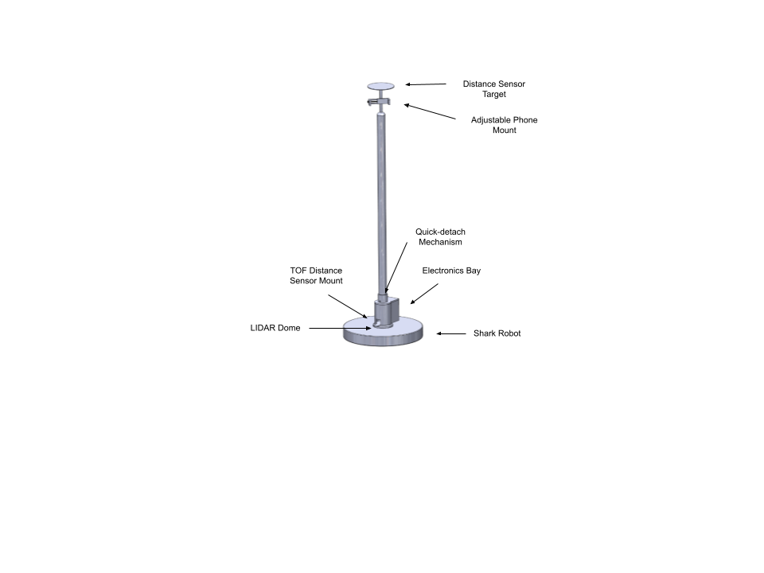

Fig. 2. CAD model of first-prototype design. Not pictured: column telescoping mechanism and phone mount stepper motor.

### Software and Networking

The system's networked components, the robot, the ESP32, and the phone, are connected via WiFi. The robot acts as both an MQTT broker and a client. A cloud-hosted web app and web server takes inputs from the phone (settings and camera output) and publishes commands to the robot over MQTT. Photos are stored in a Firebase media database and accessed through the web app. The web app also sends motor inputs to ESP32 and relays obstacle detection signals from ESP32 to the robot.

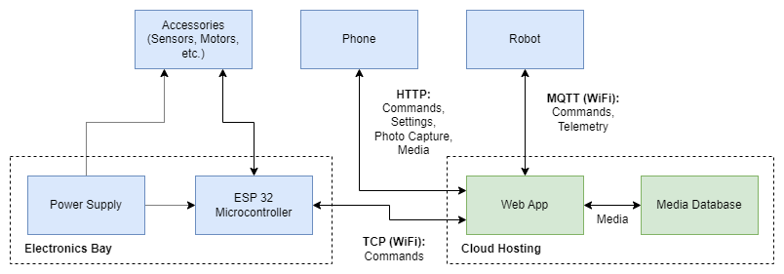

Fig. 3. Full system block diagram.

## 3.3 Camera Column Assembly

### Column Base and Electronics Bay

The column base provides a platform for the electronics module and distance sensor and allows the column to be easily removable. The 3D-printed base is intended to be installed semi-permanently. It attaches to the top of the LIDAR dome using 3M VHB tape. Using adhesive provides a secure connection and an easy means of installation (very similar to Command Strips) that does not require any tools or permanently modify the robot. Testing has shown that with the column removed, the base has a low enough profile to allow the vacuum to be used as normal. The adhesive allows removal if the user decides to completely uninstall the SharkCam for whatever reason. 3M VHB adhesive was selected for its high bond strength with plastics like ABS (the material of the LIDAR dome) and PLA (a command filament for 3D printing. Testing the VHB adhesive showed that covering the dome's surface area with tape was enough to support the entire weight of the robot (~13 lbs).

The column base and the column will connect with a quick disconnect mechanism using a spring button on the column that slots into a round receptacle on the base. When the button spring is depressed, the column is released. In order to prevent wires from needing to be connected and disconnected, electrical contacts on the base and the column will be used to transfer signal and power from the electronics to the motor at the top of the column.

The electronics bay will hold the ESP32 microcontroller, a 2000 mAh LiPo battery, the time of flight (TOF) distance sensor, and all the associated circuitry. The current design uses a 400mAh LiPo battery, but there is room for a much larger battery if needed. A breadboard will be used for initial prototyping, which will be replaced by a perfboard with soldered connections for the final prototype. The electronics bay will likely be made out of laser-cut acrylic with 3D printed mounting hardware inside. A micro USB port receptacle will allow the battery to be charged.

### Telescoping Column

The column will reach 4 ft when fully extended and will support the phone mount at the top. This height was selected to balance stability with elevation. Photos taken at a height of 4” were tested and found to provide an acceptable perspective without photos appearing to be “looking up” at the subject, even at a distance of 2” from the camera. The telescoping mechanism will allow easy storage of the product. While the design is not finalized, the mechanism will either employ lever locks, twist locks, or cam locks securing three stages of tubes. The final design of the telescoping column will likely be manufactured from either aluminum or PVC. Wires will run from the electrical contacts at the base up to the stepper motor connected to the phone mount at the top.

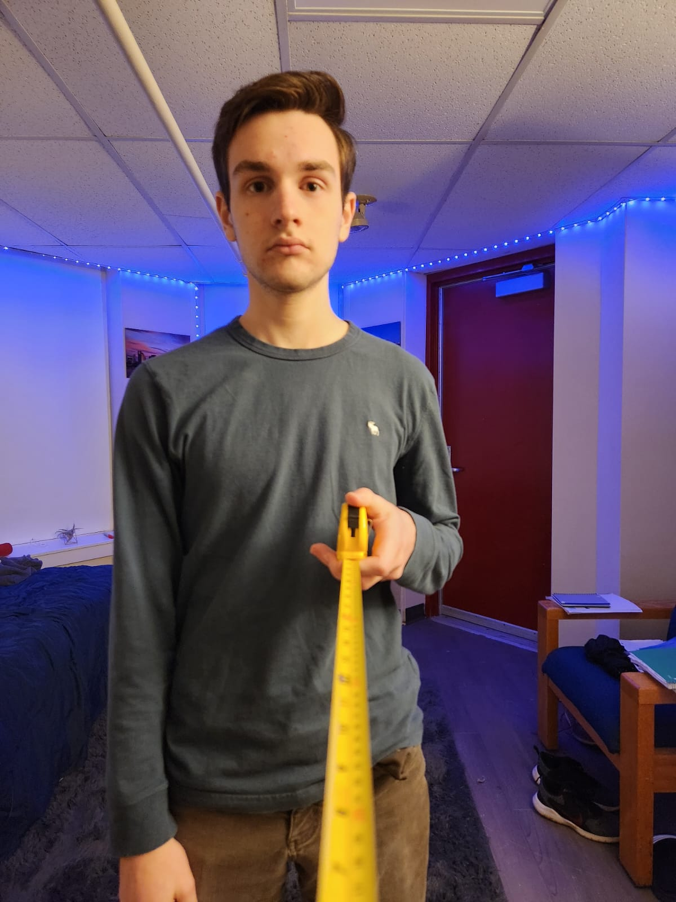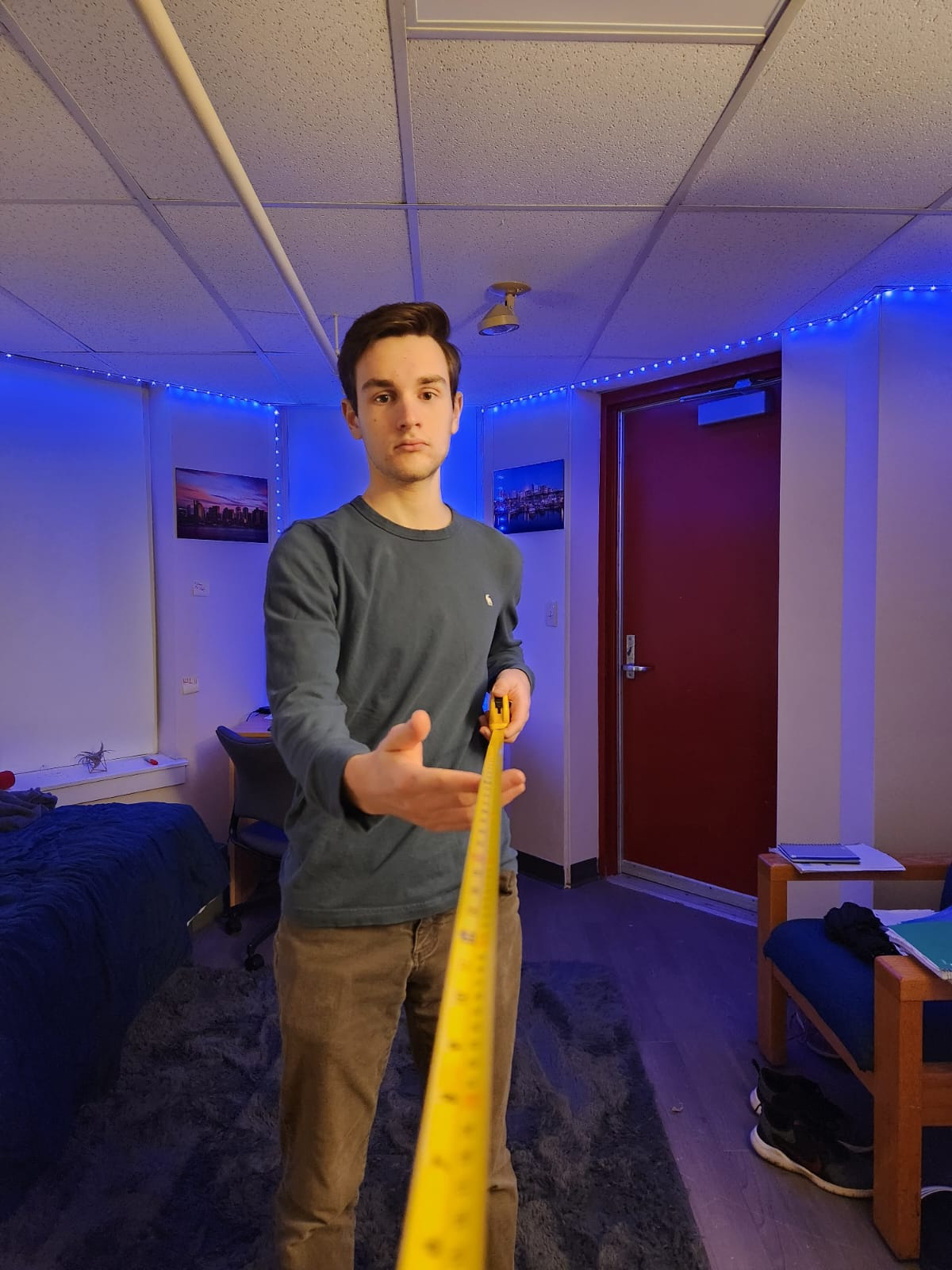

Fig. 4. Qualitative test of camera perspective at 4” height. Left: subject 2” from camera; Right: subject 4” from camera. Photos taken with Samsung Galaxy S22+ primary camera (85˚ field of view).

## 3.4 Phone Mount

The phone mount will secure a smartphone with an adjustable C-clamp mechanism. The sides of the clamp will be made of a grippy material, likely TPU or synthetic rubber pads. A stepper motor at the base of the mount will allow the entire mechanism to rotate, allowing photos to be captured in all directions without any movement from the robot. A stepper motor was chosen over a servo as control of the relative positions is required, but control over the absolute position (angle) is not necessary. Additionally, a stepper motor will allow the mechanism to rotate continuously without needing to reverse direction. At the top of the mount a round plate will provide a target for the TOF sensor no matter the orientation of the mechanism.

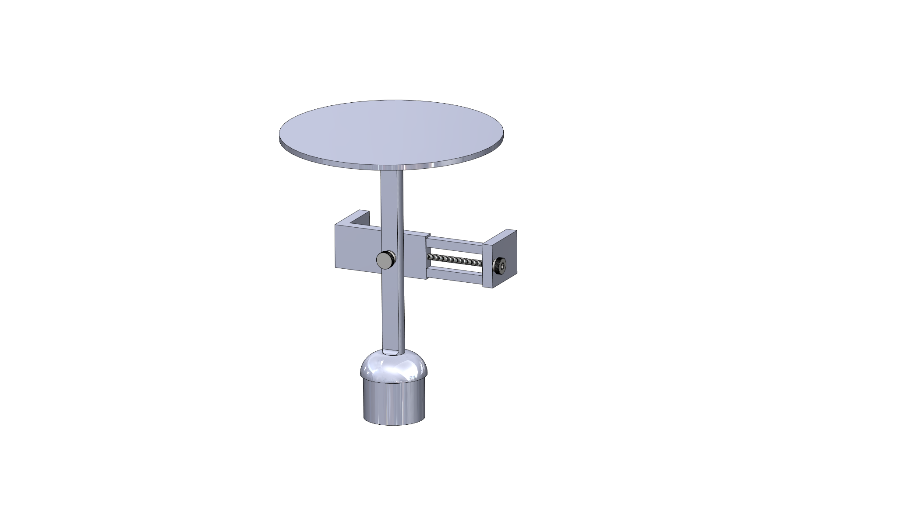

Fig. 5. CAD model of first-prototype phone mount subassembly (stepper motor and rotation mechanism not pictured).

## 3.5 Obstacle Avoidance

Since the SharkCam hardware extends the profile of the robot, it creates new surfaces that have the potential to collide into obstacles such as the overhangs of tables or desks. Such obstacles won’t be detected by the LIDAR and won't trigger one of the device’s bumpers. Testing shows that the robot will simply get stuck and start to tip itself over.

The initial design for an obstacle detection system utilized long force sensitive resistors (FSRs) that would be placed vertically along the column and connected to the ESP32 via a voltage divider circuit. When the FSRs experienced an impact creating a voltage change above a specified threshold, the ESP would send a signal to the robot through the webserver. This design presented a few problems. Attaching the FSRs to the column would interfere with its ability to telescope. This system would also leave the entirety of the phone holder exposed, necessitating the use of another sensor to protect this assembly.

The current design uses a light curtain created by an Adafruit VL53LOX TOF distance sensor. The sensor will shoot a laser vertically at a thin plate above the phone mount with the measured distance being used as a reference. When an object comes between the sensor and the plate, the sensor will detect a change in distance and send a signal to the robot through the webserver[1] to stop, rotate, move forward a specified distance, and then resume standard operation. This keeps the obstacle avoidance system separate from the column, allowing it to telescope without interference. It also protects the entire profile of the SharkCam hardware except for the thin plate which can be protected by a mechanical switch if necessary. Finally, the TOF sensor has the ability to detect potential collisions before they occur.

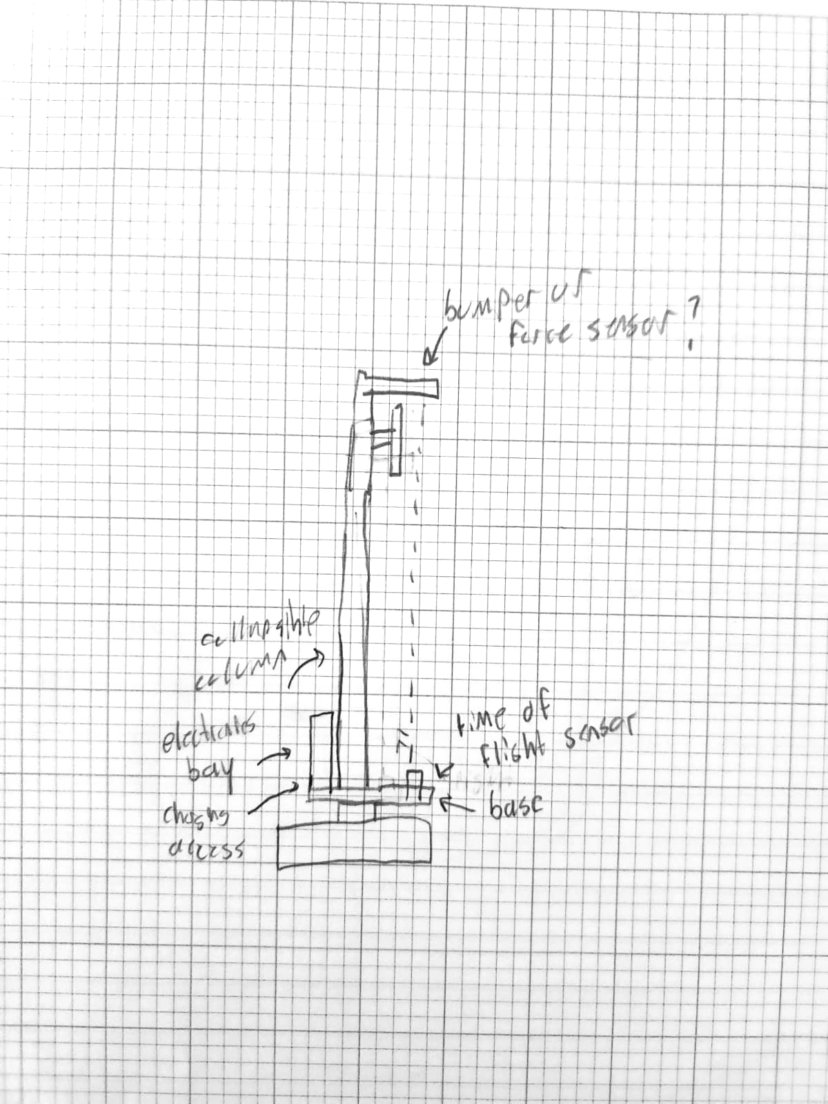

Fig. 6. Rough sketch illustrating the use of a TOF distance sensor as a light curtain.

The Adafruit TOF sensor was chosen for several reasons. It should be noted that typically a beam break sensor is used for light curtains. This sensor uses an emitter and a receiver to output a binary signal based on whether the path of the beam is interrupted. Unfortunately, there are no readily available beam break sensors that work at distances greater than 20”.

This specific sensor was chosen to make the light curtain as a beam break system did not meet the necessary requirements. A beam break sensor, the most common sensor used when making a light curtain, works with an emitter and a receiver. Unfortunately, these sensors either do not work at distances of more than 20” or are very expensive. Other options include ultrasonic sensors or LIDAR. Ultrasonic sensors have better range, but a wide cone of detection, which could lead to a high false positive rate. LIDAR sensors are expensive and offer more precision than is needed for a light curtain. On the other hand, the selected TOF sensor is inexpensive, can work up to 2 meters in its long-range mode, and integrates easily with the ESP32 thanks to its use of the I2C protocol.

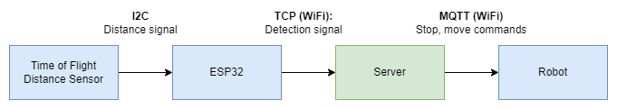

Fig. 7. Obstacle avoidance device chain.

## 3.6 Web Application

A Flask-based web application will handle all communication with the robot using the API provided by SharkNinja. The web app will also access the phone’s camera (through OpenCV), provide a user interface, and communicate with the microcontroller to send motor commands and receive obstacle detection signals. A web app was selected because it is platform-agnostic, will save development time, and matches the expertise of the software team. Flask was chosen for the back-end due to its flexibility, the availability of documentation, and its native support for APIs (unlike Django). The web application will be containerized and run on a Firebase cloud server, with cloud-based photo storage also handled by Firebase.

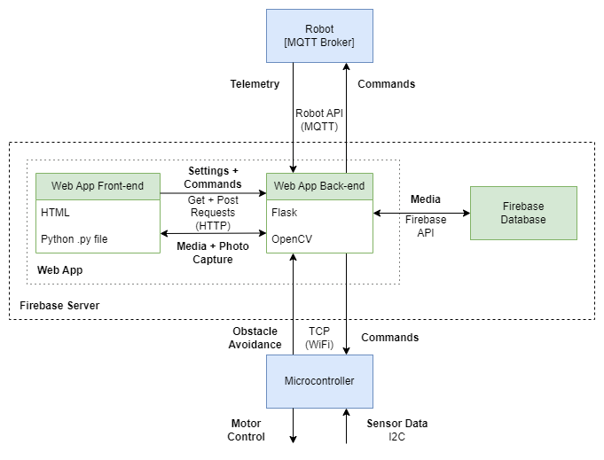

Fig. 8. Network block diagram.

The web app's front-end serves the user interface and consists of pages to view photos, capture photos, and configure robot settings. To ensure privacy, photos will be locked behind codes unique to each event, and the user will have to input the unique code to view any photos. Photo capture will be automated, with options to configure the number of photos taken per interval, the time between photo captures, and the time spent capturing photos available on the settings page. The settings page will also allow the user to begin the robot’s room mapping process, which is essential to the robot’s autonomous navigation.

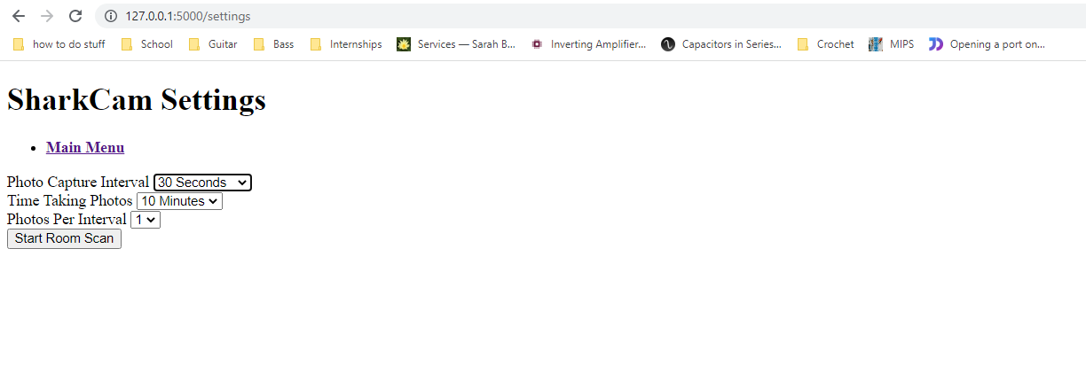

Fig. 9. Web app settings page.

A page dedicated for taking pictures features a viewfinder, and the option to manually trigger a photo capture.

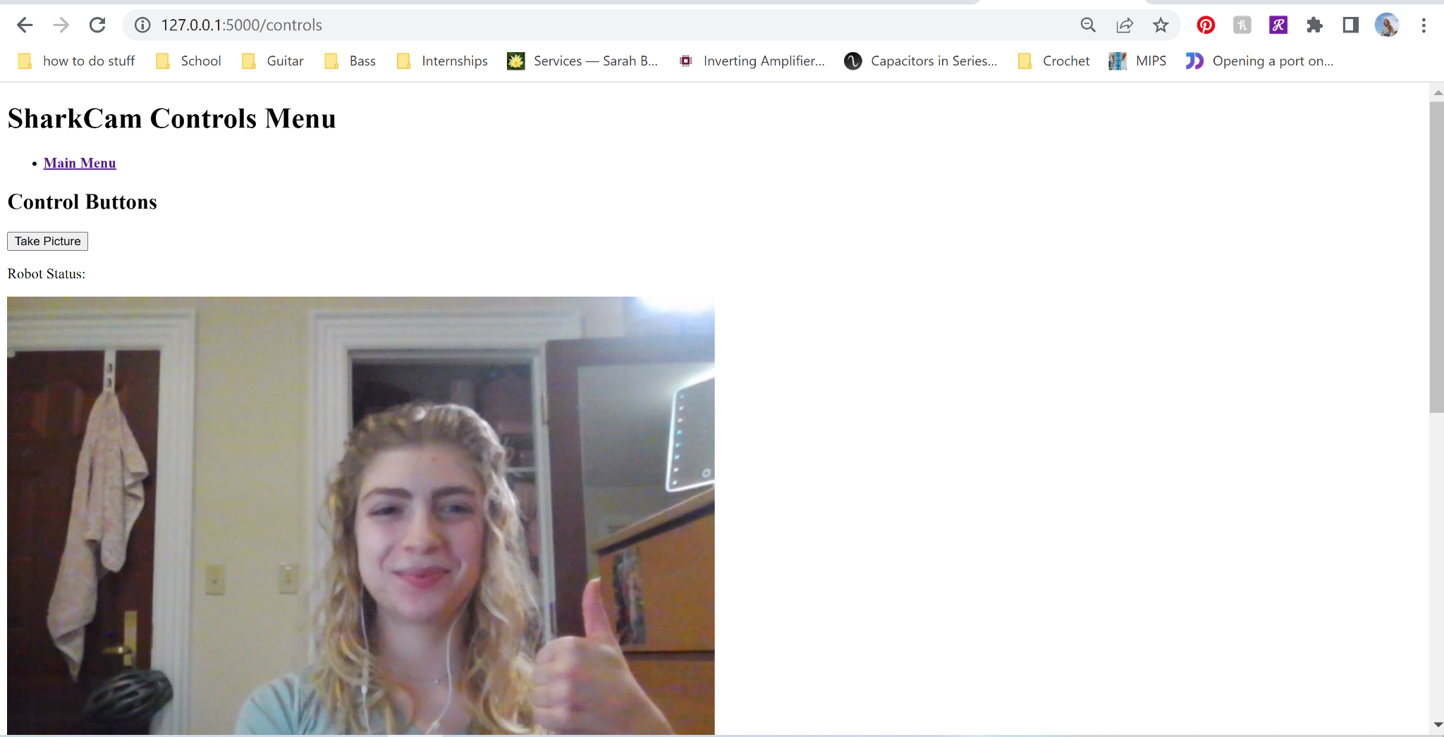

Fig. 10. Photo capture page with image preview.

An image gallery page is dedicated to upload and display pictures directly on the web app. This is where the customer would go after the event to see the pictures.

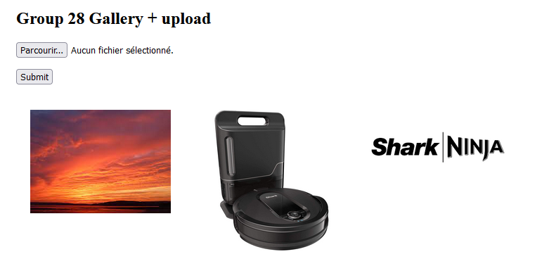

Fig. 11. Image gallery screenshot with 3 placeholder images.

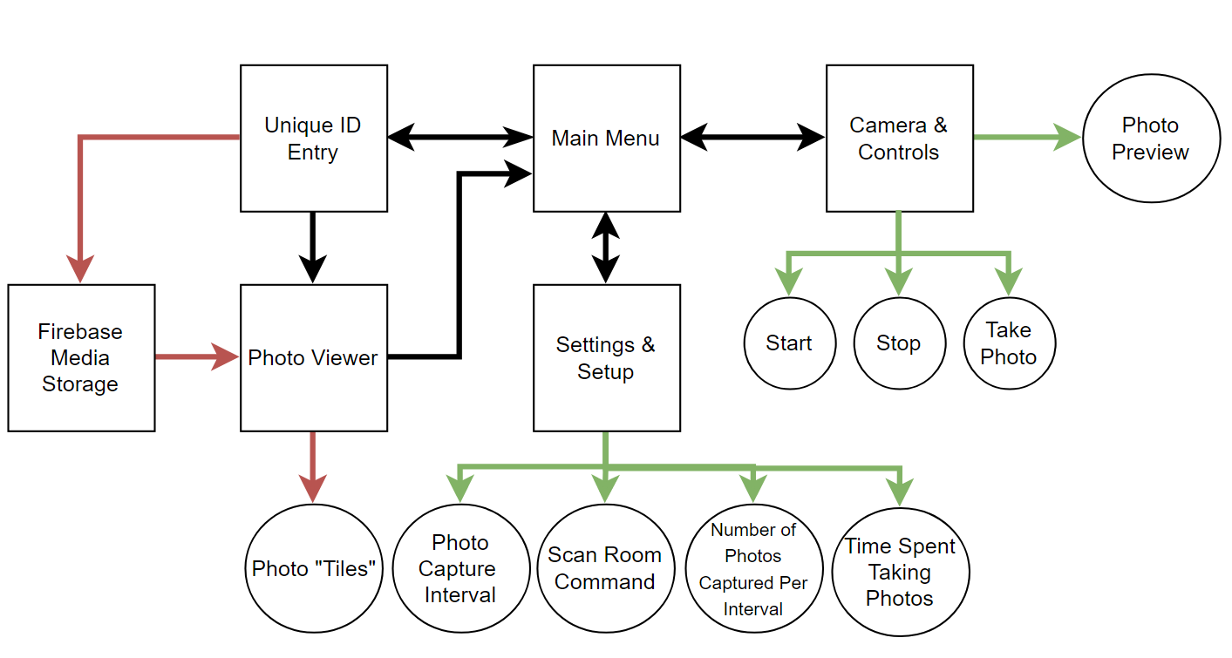

Fig. 12. Schematic of web app navigation and settings.

## 3.7 System Routines and Behavior

In order to make the best use of the robot’s capabilities, and because of the limitations of the API, the SharkCam will lean on the existing autonomous functionality of the robot as much as possible. The main photo capture routine will trigger the robot's cleaning mode, where it will traverse its mapped area, ensuring good coverage of the entire event space. If the event space has not been mapped, the user will have the option to use the robot’s explore more. Using these built-in operation modes will enable all of the device's sensors and autonomous navigation algorithms. Based on parameters set by the user, the app will take pictures at specified intervals. At each interval, the robot will pause, and the phone mount will rotate to capture photos in all directions.

When an obstacle is detected, the autonomous cleaning (or exploring) will be interrupted, and the server will send manual commands for the robot to turn in place and move a specified distance. Future testing will be conducted to calibrate these values. The user settings will include interval time, captures per interval, and total capture time. The vacuum function can also be enabled/disabled, providing the option to clean while photographing or to turn off the vacuum for quieter operation.

## 3.8 Stretch Goals Beyond Minimum Viable Product (MVP)

### Location Data Scraping

Robopad is a developer interface used to test and calibrate SharkNinja robots. While the robot API does not currently support location data, the Robopad web GUI does. It produces a near real-time (~1hz refresh) png file of the mapped area with the robot’s location. This data could be scraped every time a photo is captured to save location data and allow the user to view a map of all photos taken at an event. A script to find the coordinates of the red dot representing the robot would allow the location to be extracted from each image. Since Robopad is accessed by connecting to the robot’s local IP (port 8080), the difficulty is determining how to access it when the server is cloud-hosted. Since the phone will be connected to the local network, there may be a way to perform this on the client side or by using port forwarding.

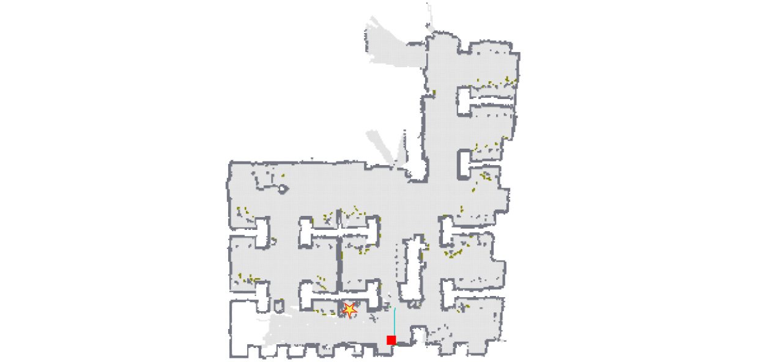

Fig. 13. PNG from Robopoad of the PHO133 lab mapped by the robot. Star represents the base station and red dot represents the robot’s live location.

### Face Tracking

OpenCV features built-in pre-trained face detection algorithms. These classifiers could be used to automatically orient the phone camera at faces when they are detected. The difficulty is that this would require implementing a PID controller for the motor. The team has limited experience with PID control systems, and the latency from the cloud-hosted server will likely have a severe negative impact on the performance of PID.

### LED Indicator Lights

No functionality of the MVP relies on LED lights, however they could enhance the aesthetics and user experience of the product.

LEDs could serve as simply party lights or they could be programmed to communicate information such as when the device is about to take a photo. The addition of a microphone could even allow the lights to sync to music.

### IR Remote Control

Adding an IR receiver and remote control could allow the user to stop the robot without needing to remove their phone from a moving robot, using a second phone with the web app, or pressing the Dock button on the base of the robot.

# 4 First Semester Progress

## 4.1 Experimentation and Research

After meeting with SharkNinja and being provided with a control library, the team was informed that directing the robot to a specific location with its built-in autonomous navigation was not possible. Team experimentation has confirmed that as well: the libraries provided by SharkNinja do not have the ability to modify the autonomous navigation process, and attempting to scrape navigation data from another application, such as Robopad, has not been successfully attempted.

OpenCV photo-capture experimentation has been successful. After running OpenCV applications locally, a webpage implementation has been routinely tested with promising results. The web application consistently captures photos, and displays them to users.

Experimentation also tested the robot’s ability to exit autonomous navigation, complete an action, then re-enter autonomous navigation; the team needed to confirm that it could interrupt the robot’s routine without it getting “lost” in a room it had already mapped. Interrupt testing was successful, and the robot maintained knowledge of its surroundings after being told to stop navigating and execute a different action.

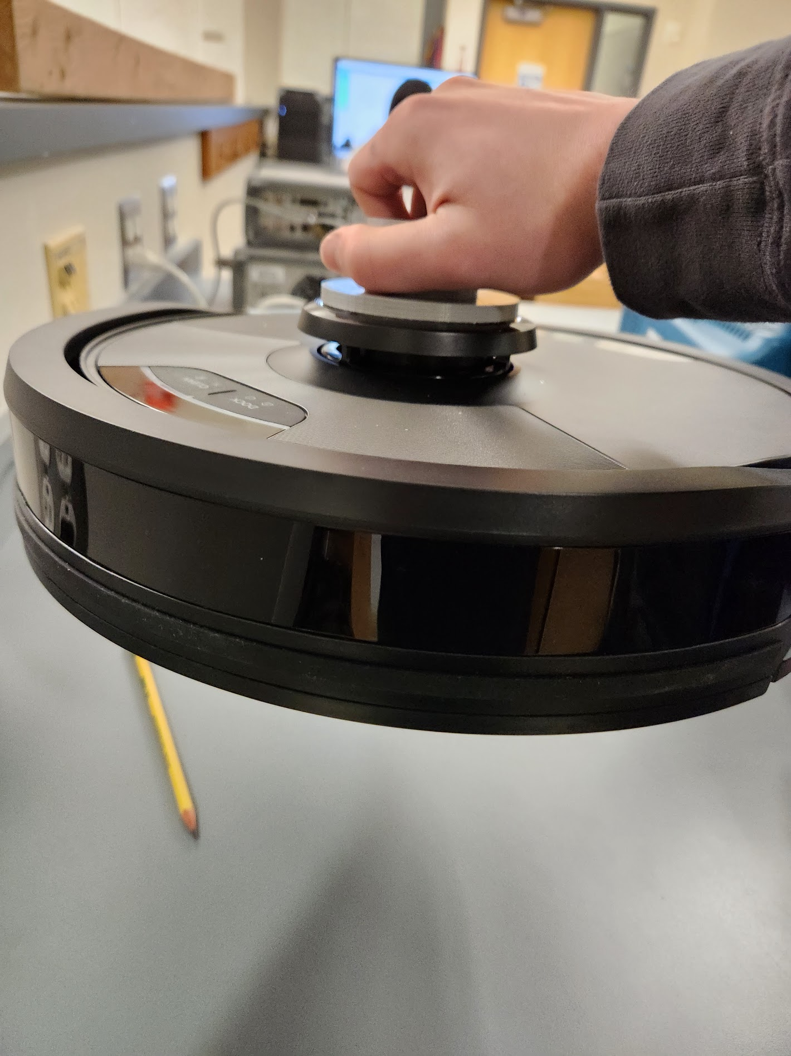

Fig. 14. Test of 3M VHB tape strength. The adhesive is able to secure the prototype base and support the weight of the robot.

The mechanical team has completed testing of both the bumper on the LIDAR dome as well as the VHB adhesive. Originally, there was an idea that the bumper on the LIDAR dome could be triggered if the column attachment was rigid enough. By making the attachment rigid, however, it was determined that the product is more susceptible to falling over. When the attachment was made less rigid, it was determined that the attachment would be unable to properly transfer the load from the column into the LIDAR dome. Therefore, using the bumper on the LIDAR dome was no longer feasible, and an alternative solution was made. The VHB attaches the quick disconnect mechanism to the top of the LIDAR dome on the robot. As such, it is important that the connection is nondestructive and simple to install, but strong enough to support all loads. It was therefore crucial to test the strength of this connection. The testing that was conducted showed that the VHB connection was so strong that it could even support the entire weight of the robot. The information from the mechanical testing was enough to support the decision to use the VHB adhesive as a means of connecting the product to the robot.

## 4.2 Rapid Prototyping

A preliminary implementation of the column base and column has been developed. The base was 3D printed and mounted using 3M VHB adhesive, while the column was cut from PVC. This allowed the team to determine the optimal height of the camera column for taking photos, as well as the stability of the column once mounted in the base.

After rapid prototyping, the team determined that the column was unwieldy because it could not collapse, and that friction was not enough to keep the column from wobbling in the base. As such, the team prototyped a new column-base configuration. This new configuration is partially made from a bottom spring which is the main part that holds the column to the column base part. As for the column itself, it is attached through epoxy.

## 4.3 Software Development

The software development process has gone smoothly throughout the semester, and mostly to plan. At the beginning of the semester, the team decided to develop a web application due to the fact that it is operating system agnostic. From there, first semester work focused on the structure of the web application and implementing photo-capture functionality.

The team decided to use a Flask framework and Python to code the web application. While Flask is not the industry standard, its ease of use and widely available and diverse libraries have allowed for its rapid development. Currently, the web application has pages to view photos, configure robot settings, and capture photos, as well as a main menu.

OpenCV, a Python photo-capture library, has been implemented to take photos directly from the web application. Essentially, it embeds a stream of photos captured from the user’s camera as images in the “Photo Capture” page. This allows users to preview and pose for their photos. After a trigger, the photo captured appears below the preview window.

In terms of robot control, the team has received a custom Python library from SharkNinja that allows for manual robot navigation and action triggering. This library and application commands will be used in-tandem to configure robot behavior.

# 5 Technical Plan

## 5.1 Hardware

Designs for the next iteration of prototypes will be finalized by the end of January so that manufacturing and testing can begin. Starting as soon as January 19, the mechanical team is in charge of using the 3D printers to implement the STL file for column base. Using a FDM printer this will roughly take about two to three days to actually be manufactured. The phone mount on the other hand will be made by using the milling machines at the EPIC facility to integrate the designs into the SharkCam. The holes of the thumb screw and lead screws will be tapped after the shapes of the phone mount are milled. Using epoxy the side flanges will also include a rubber padding which will add extra holding friction so the phone does not slide up and down. This process itself should also be completed within two to three days. In order to get the product ready for April, rapid prototyping will be done with an emphasis on an ergonomic design for the customer. The team plans to have the first prototype of the column and column base as soon as the first week of February. As for the phone mount, the first design is very much more complex. Due to this the timeline for this to be manufactured is the second to third week of February.

The accommodating final tests will begin the second week of February. This will hold a full house run of the SharkCam including the column base, column, and phone mount. This will also include the distance sensor for collision detection and a stepper motor for the full 360 phone spanning.

* Testing
  + New collision Detection
    - 1/22/2023
  + Stepper motor speed
    - 1/25/2023
  + Column strain test
    - 1/22/2023
  + Quick connect system strain test
    - 1/22/2023
  + Phone mount strain test

The strain testing will be done mainly through Solidworks using their FEA simulation tool. This will allow us to integrate the materials physical properties and get a good reading on how much force the column, column base and phone mount and each take. This will mostly be finalized as soon as the third week of February. These testing’s will also allow the team to accurately test for weakness in the design where new iterations of the parts can then be made in the last and final week. After the simulations are done, that same week, a physical test will also be done by dropping and hitting the columns at specified forces which can be measured through a force sensor.

## 5.2 Software

The structure of the web application has been implemented, and is unlikely to undergo a drastic change. In the future, the application will use the Firebase API to store photos, and the photo viewing page will use the same API to load media. The entire application will be styled with CSS, containerized, and deployed on a Firebase server to ensure its (near) constant operation.

A custom Python library will be used to control the robot, and has been provided by SharkNinja. Future software development will integrate this library with the web application and microcontroller code so the robot’s collision detection and room mapping routines can be executed. Software development will also include unique code generation for photo privacy, and networking between application, robot, and microcontroller with MQTT protocol will be implemented.

# 6 Budget Estimate

## 6.1 Budget Estimate

TABLE 1

LIST OF COMPONENTS NEEDED FOR PRODUCT DEVELOPMENT

| Item# | Name | Cost |
| --- | --- | --- |
| 1 | Time of Flight Distance sensor | $14.95 |
| 2 | ESP 32 featherboard microcontroller | $20.95 |
| 3 | 3M VHB Tape* | $7.98 |
| 4 | Stepper Motor * | $6.90 |
| 5 | 3 Springs | $23.94 |
| 6 | Battery | $6.95 |
| 7 | Firebase cloud server estimated hosting costs | $50.00 |
| 8 | Butterfly Bolt | $7.49 |
| 9 | Threaded Inserts | $9.99 |
|  | Total Cost | $149.15 |

Items marked with * are team donations or supplies available to team

## 6.2 Tentative BOM

TABLE 2

BILL OF MATERIALS FOR FINAL PROTOTYPE

| Item# | Name |
| --- | --- |
| 1 | Time of Flight Distance sensor |
| 2 | ESP 32 featherboard microcontroller |
| 3 | 3M VHB adhesive |
| 4 | Stepper Motor |
| 5 | 3 Springs |
| 6 | Battery |
| 7 | Firebase cloud server estimated hosting costs |
| 8 | Butterfly Bolt |
| 9 | Threaded Inserts |
| 10 | Column |
| 11 | Column Base |
| 12 | Phone Holder |
| 13 | ABS filament |

# 7 Appendix

## Appendix 1 - Engineering Requirements

TABLE 3

REQUIREMENTS FOR MVP

| Requirement | Rationale |
| --- | --- |
| navigate event area and capture photos autonomously | core functionality - goal is to capture candid photos without user input |
| store photos and allow user to view them | core functionality - accessory is meant for events and parties and social aspect of sharing photos is key |
| provide password protected portals | photos are often private, and many times people don’t want them to be public |
| avoid obstacles | increased profile of device exposes it to obstacles like people and overhangs that LIDAR or bumpers won’t detect |
| does not interfere with robot’s sensors or other systems | robot navigates by LIDAR - obstructing sensor will interfere with navigation  robot has mechanism to empty dust into base station - interfering with this system will produce error |
| 90 minute battery life | halfway between manufacturer rated battery life (60 min) and real world battery life assessed by reviewer (120 min) [2] |
| less than 15 lb load on robot | maximum load that robot ++++can support (according to manufacturer) without damaging LIDAR dome or straining motors |
| column can handle light impacts | device will potentially be operating in close proximity to people not paying attention - needs to withstand being impacted by a partygoer’s arm |
| no damage or permanent modifications to robot | accessory should not force user to permanently modify an expensive device or interfere with normal operation |
| no tools required for user assembly | aftermarket accessory must be simple for user to install |
| quick assembly of column for normal use (quick disconnect system) | users won’t use the product if assembling the product to the robot takes a long time in normal use |
| one-size-fits-all camera mount | the camera mount must be able to accommodate all size phones as limiting the usable phones would severely decrease the consumers that could use the product |
| can be controlled completely by web app | shouldn’t require user to switch between multiple apps or use buttons on device |

## 7.2 Appendix 2 - Gantt Chart

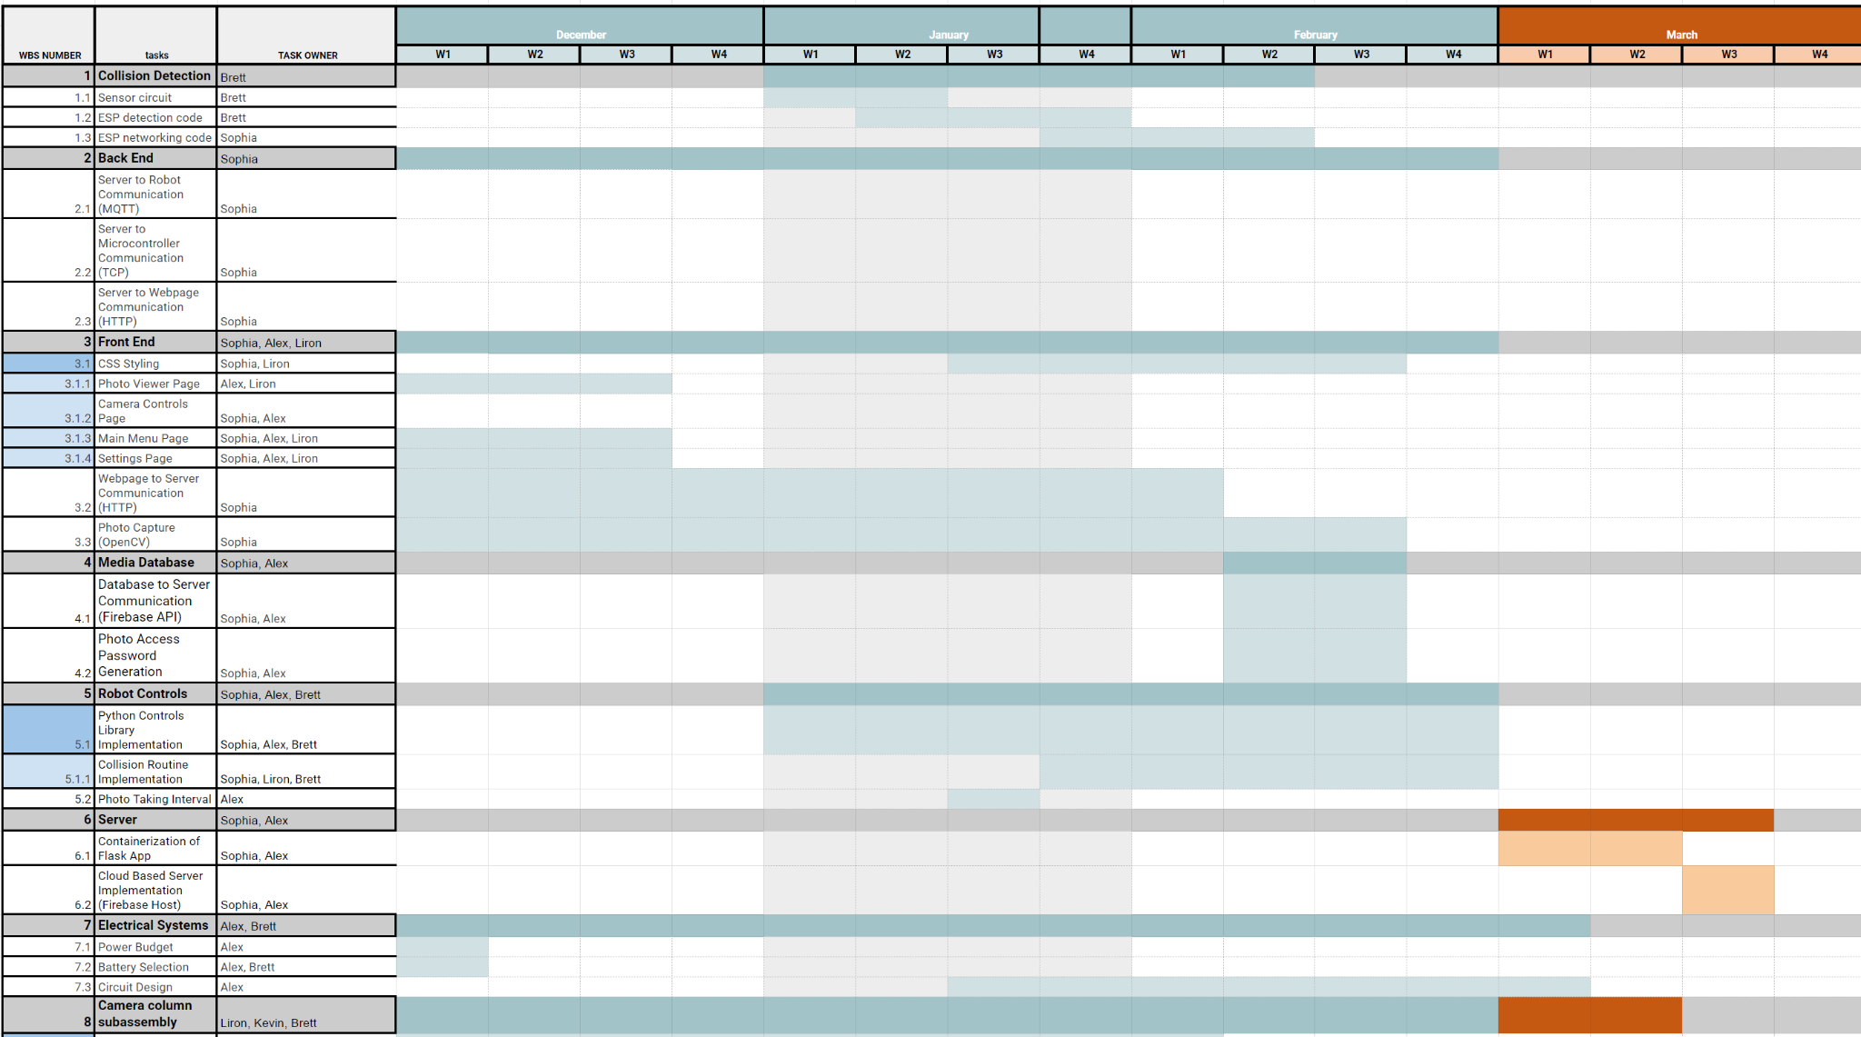

## 7.3 Appendix 3 - Power Budget

TABLE 4

ESTIMATED POWER REQUIREMENTS

| Item# | Name | Voltage (V) | Current (A) | Power (W) |
| --- | --- | --- | --- | --- |
| 1 | Time of Flight Distance sensor | 2.80 | 0.03 | 0.08 |
| 2 | ESP32 featherboard microcontroller | 3.30 | 0.25 | 0.83 |
| 3 | Stepper Motor | 5.00 | 0.24 | 1.20 |
| 4 | 3 LEDs | 2.00 | 0.05 | 0.09 |
|  | Total Power |  |  | 2.20 |

Given the requirement of a 1.5 hour battery life, the energy requirements of this prototype’s circuit is $2.20 *1.5 * 1000 =3300 mWh.$

**Acknowledgment**

The authors wish to thank Brendan Uchendu (fmr. SharkNinja), Guy DiPietro, Michael Finnegan, Raghav Hari Krishna, and Yiming Zhang of SharkNinja. The authors also wish to thank Osama Alshaykh, Michael Hirsch, and Alan Pisano of the BU Department of Electrical and Computer Engineering, and Anna Thornton of the BU Department of Mechanical Engineering.

**References**

1. “Global instant print camera market to 2029 - featuring Fujifilm Holdings, Leica Camera and Hewlett-Packard among others - researchandmarkets.com,” Business Wire, 31-Mar-2022. [Online]. Available: https://www.businesswire.com/news/home/20220331005503/en/Global-Instant-Print-Camera-Market-to-2029---Featuring-Fujifilm-Holdings-Leica-Camera-and-Hewlett-Packard-Among-Others---ResearchAndMarkets.com. (Accessed: 11-Dec-2022).
2. “Shark AI Self-Empty XL RV2502AE Review,” PCMAG. https://www.pcmag.com/reviews/shark-ai-self-empty-xl-rv2502ae (accessed Dec. 11, 2022).

**Section Primary Authors**

Executive Summary - B.S.

Intro - L.D.

Concept Development - A.P

System Description - B.S.

First Semester Progress - S.D.

Technical Plan - K.V.

Budget Estimate & BOM - A.P.

Engineering Requirements - B.S.

Figures & Formatting - B.S.

1. In theory, since the ESP32 and the robot are on the same network, the microcontroller could send these commands directly to the robot. The implementation of the robot’s API we were provided is in Python, however, and we plan to use the Arduino Core with the ESP32. We have chosen to route all commands to the robot through the webserver since the API will already be set up there. This can be re-evaluated if latency is found to be an issue.